Bridges in Mathematics
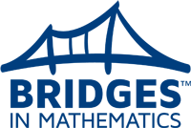
Online Information
www.mathlearningcenter.org

General Information:
- More information on Bridges in Mathematics, 2nd edition:
www.mathlearningcenter.org/bridges/overview
- More information on Number Corner, 2nd edition:
www.mathlearningcenter.org/nc/overview
Support for Families:
- Unit letters by grade level:
www.mathlearningcenter.org/support/bridges
- Online resources by grade level:
http://www.mathlearningcenter.org/resources/families
- Open-ended math modeling apps:
http://catalog.mathlearningcenter.org/apps
GPS Information on the Bridges adoption can be found at:
www.guilfordschools.org
Teaching and Learning
Curriculum
Math
Resources

